Checkout - SWR BKR 2B - Primary Block
Safety Procedures
OFCI Equipment Checkout Safety Plan
- Pre-energization inspection is completed and the equipment is ready to be energized
- Perform ORM with all personnel involved and review procedure as well as backout plan. Identify muster point
- Verify appropriate safety zones and barricades are in place in accordance to our control scheme
- Area access control is in place
- Equipment signs - nameplate, name tag, arc-flash labels, and safety signage - are installed correctly
- Verify proper operation of test equipment
- Safe work conditions have been established and verified prior to energization
- Work with Vendor support team

Equipment Tag Name | Equipment Manufacturer | Equipment Model
RIC2_DC6_SWR_B1_BKR_2B | ABB | EMAX 4.2

Section A - Analog Control Points
Data Point | Field Value | SCADA Value | Values Match | Incident Report No. / Notes
Data/Amps_A
Data/Amps_Avg
Data/Amps_B
Data/Amps_C
Data/Amps_G
Data/Amps_N
Data/kVA
Data/kW
Data/kWh
Data/PF
Data/Pos
Data/Status
Data/Volts_AB
Data/Volts_AN
Data/Volts_BC
Data/Volts_BN
Data/Volts_CA
Data/Volts_CN
Data/Volts_LL_Avg
Data/Volts_LN_Avg
Section B - Digital Control Points
Data Point | Status Simulated / Command Sent | Status Verified in SCADA | Pass/ Fail | Incident Report No. / Notes
Data/CB_Position
Data/Comm_Fail
Data/Status_Changed
Section C - Alarm Points
Data Point | Status Simulated | Status Verified in SCADA | Pass/ Fail | Incident Report No. / Notes
Data/Breaker_Status_Alarm
Data/CB_NC
Data/CB_NO
Data/Percent_Load
Data/Tripped
Section D - Memory Points
Data Point | Status Simulated/ Command Sent or Field Value | Status Verified in SCADA or SCADA Value | Pass/ Fail or Values Match | Incident Report No./Notes
Data/Amp_Rating
Data/CB_Normal_State
Data/Feeds
Data/Nominal_Volts

SCADA Evidence Screenshots
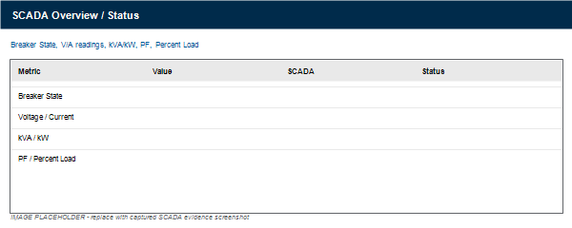
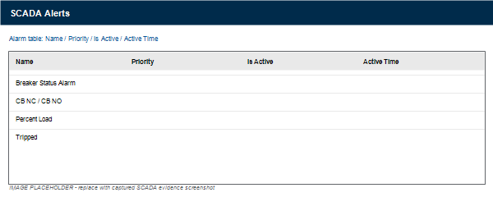
Punchlist Items
# | Description | Assign To | Status | Incident Report No. / Notes
1 |  |  | Choose an item.
2 |  |  | Choose an item.
3 |  |  | Choose an item.
4 |  |  | Choose an item.
5 |  |  | Choose an item.
6 |  |  | Choose an item.

M.C. Dean | Engineer | QC Representative
Print Name:
Signature:
Date:

